**M. Varshith**

**192211780**

**EXP NO 1**Create a simple cloud software application for Flight Reservation System using any Cloud Service Provider to demonstrate SaaS include the necessary fields such as one-way, round trip, From, to, Departure, Departure, Travelers & Class, Fare Type, International and Domestic Flights etc.

**PROCEDURE**

**STEP 1** GO TO ZOHO.COM

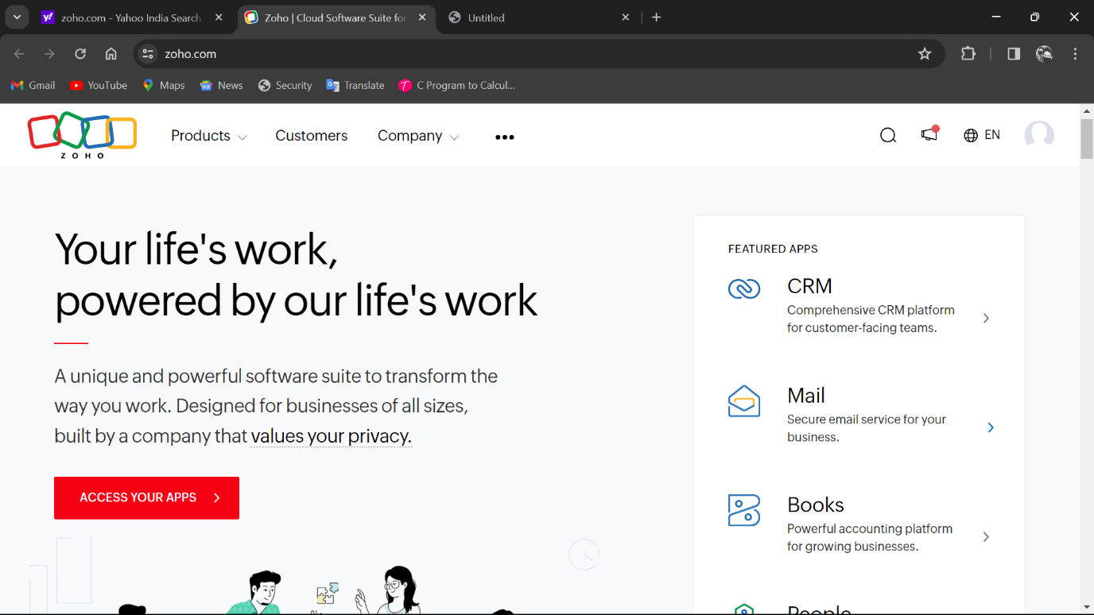

**STEP2** LOGIN TO THE ZOHO.COM

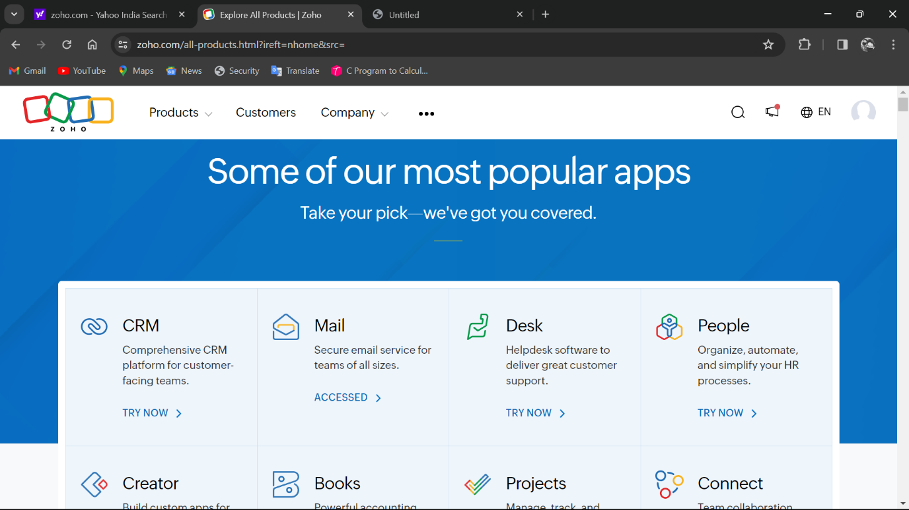

**STEP3**SELECT A CREATE FROM SCRATCH

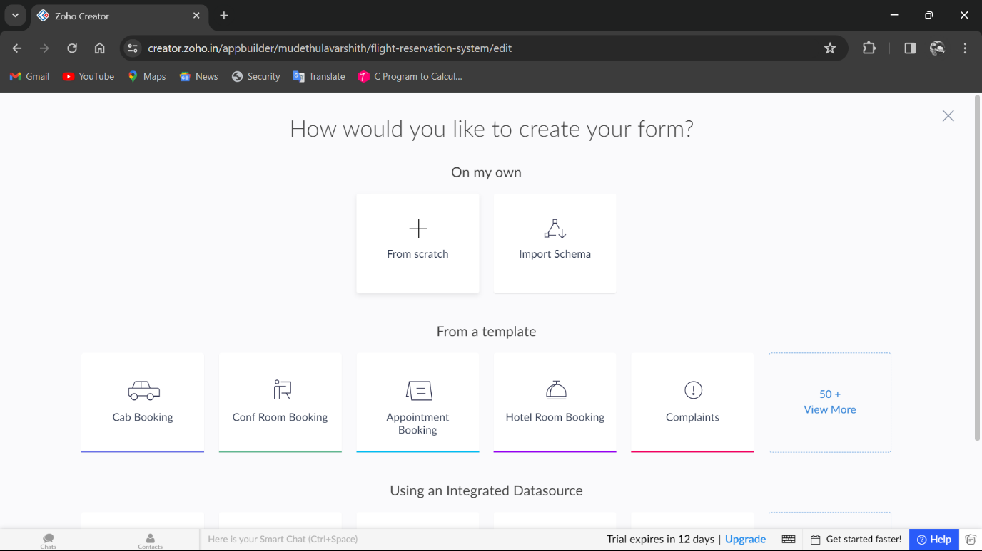

**STEP 4**SELECT APPLICATION NAME AS FLIGHT RESERVATION SYSTEM

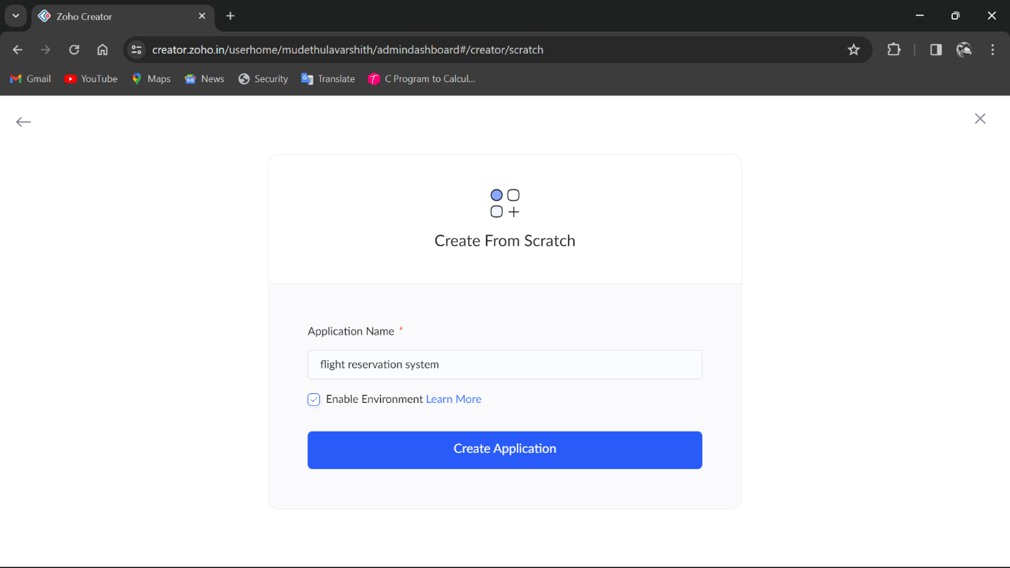

**STEP 5** CREATE A NEW FORM

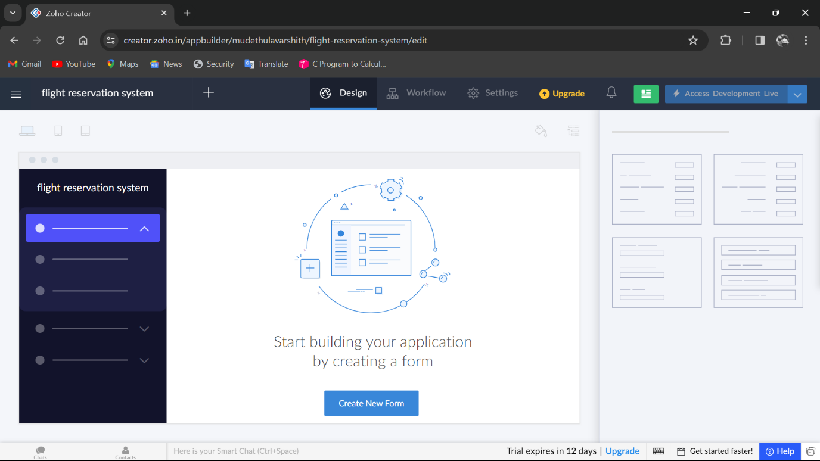

**STEP 6**SELECT BASIC FIELD FROM GIVEN BELOW AND DEVELOP APPLICATION

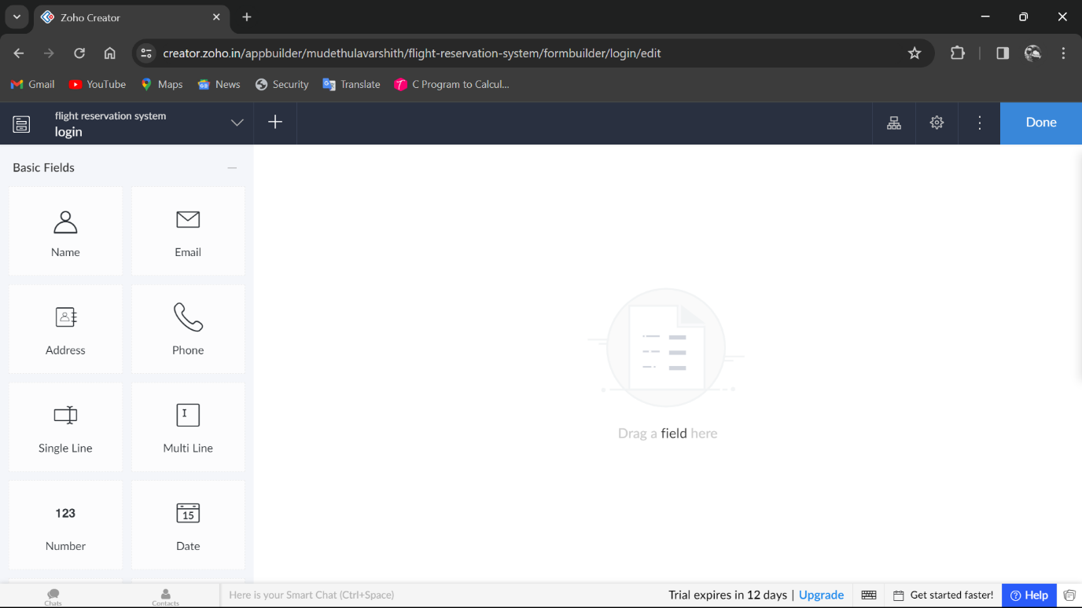

**STEP 7**THE SOFTWARE HASE BEEN CREATED LOGIN PAGE

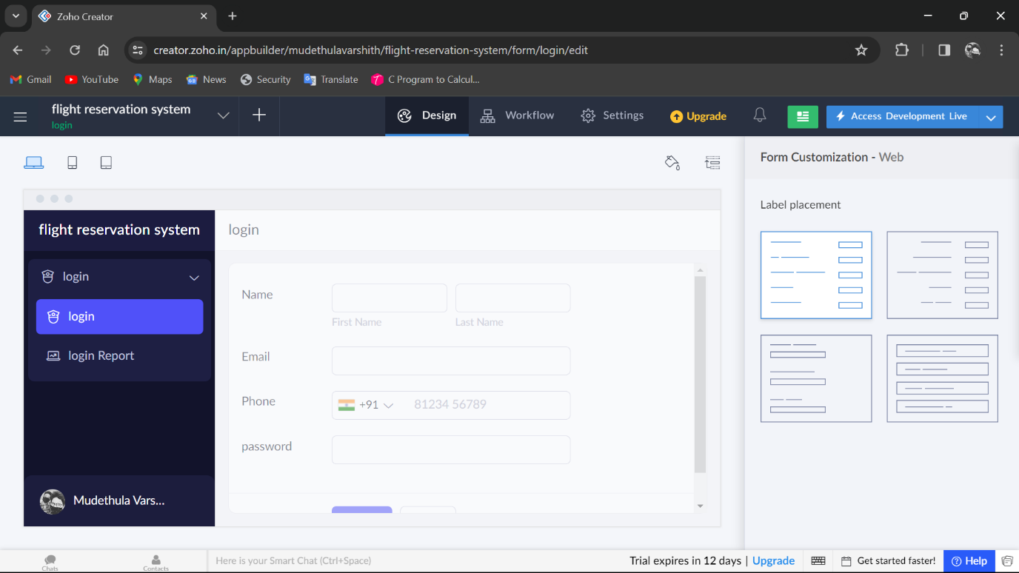

**STEP 8**THE SOFTWARE HASE BEEN CREATED WHERE TO WHERE

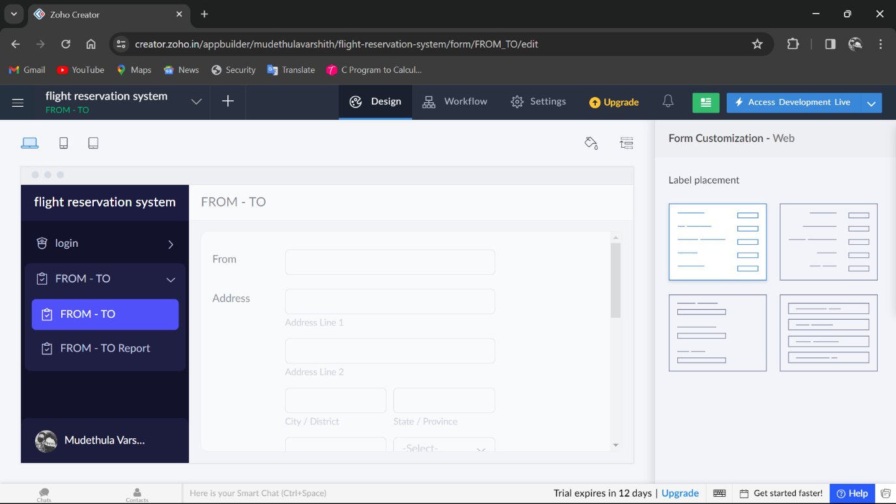

**STEP 9**THE SOFTWARE HASE BEEN CREATEDAVAILABILITY OF FLIGHTS AND SEATS

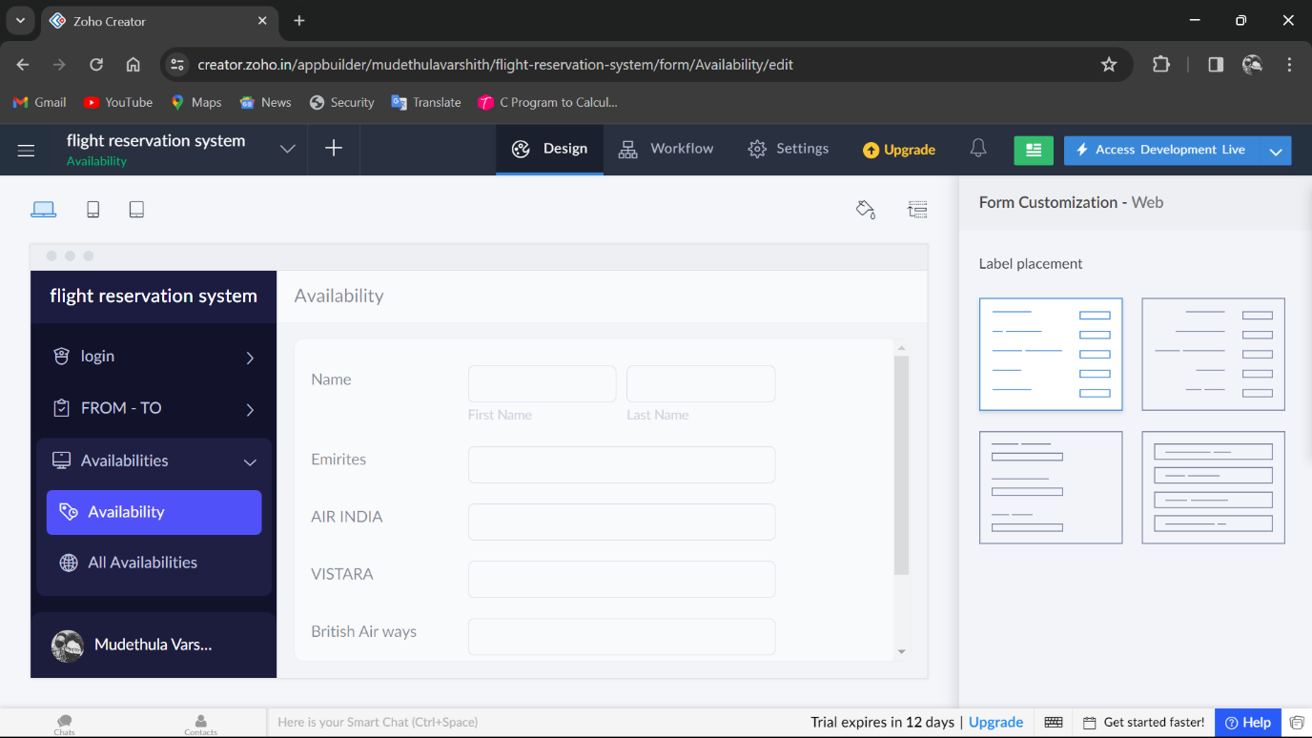

**STEP 10**THE SOFTWARE HASE BEEN CREATEDBOOKING

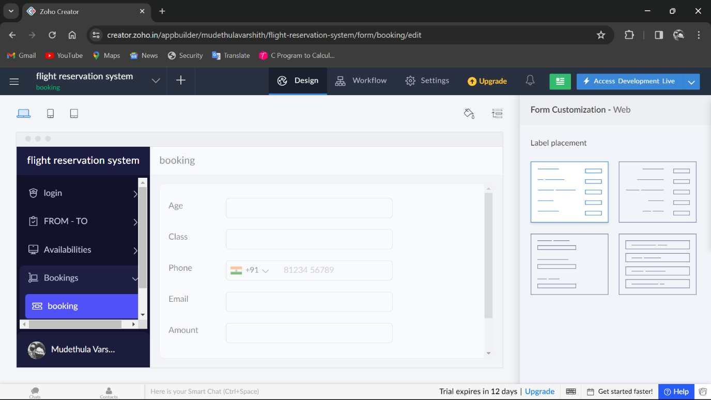

**STEP 11**THE SOFTWARE HASE BEEN CREATEDPAYMENTS

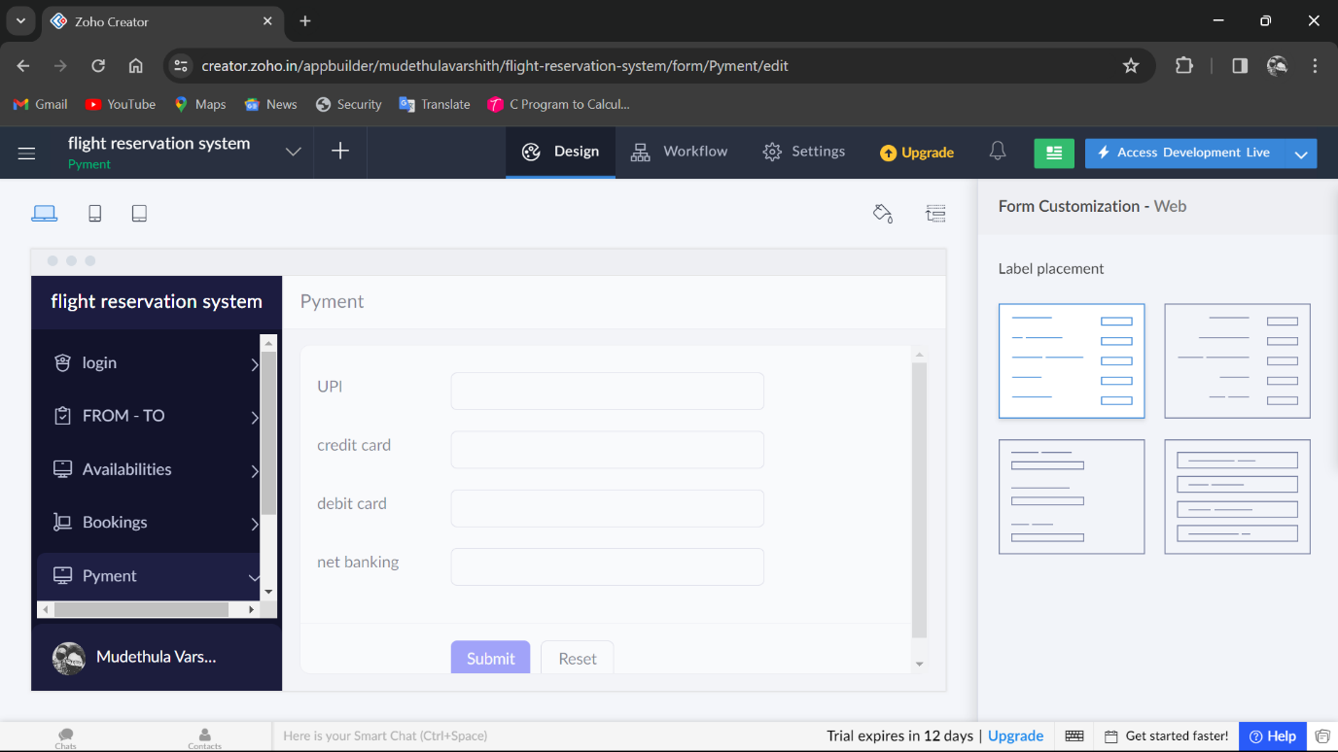

**STEP 12**THE SOFTWARE HASE BEEN CREATED

